Information for Homeowners and Tenants
 When your home is infested with bed bugs we always recommend working with a Pest Management Professional. Bed Bugs are very difficult to control on your own so it is a good idea to work with a professional. If you are a tenant you should contact your landlord right away about the bed bug infestation. Once you have notified your landlord of the situation they should work with a Pest Management Professional to treat your home. When you are working with a Professional it is important to follow any instructions they give you, following these instructions will make it easier for the professional to control the bed bugs in your home.
We know it can be very expensive to hire a Pest Management Professional so we are providing some information on Bed Bug Control in Residences to help reduce the number of bed bugs in your home. These steps will not eliminate bed bugs but they may help you reduce the number of bugs in your home.

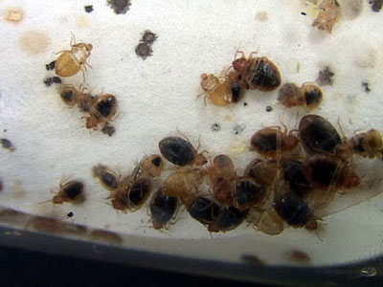
We highly recommend against using over the counter insecticides for treating bed bugs in your home. These insecticides are not very effective. If you are using an insecticide always read the entire label and follow all instructions. Do not use garden and agricultural insecticides in your home. Here are some additional tips on what NOT to do when you have bed bugs in your home.
If you are not sure if you have bed bugs or not check out the information on identifying bed bugs.
How to Prevent Bed Bugs from Entering your home provides information on some simple steps that can be taken to prevent bed bugs from entering your living space.

